**Week 2**

**Linear Regression**

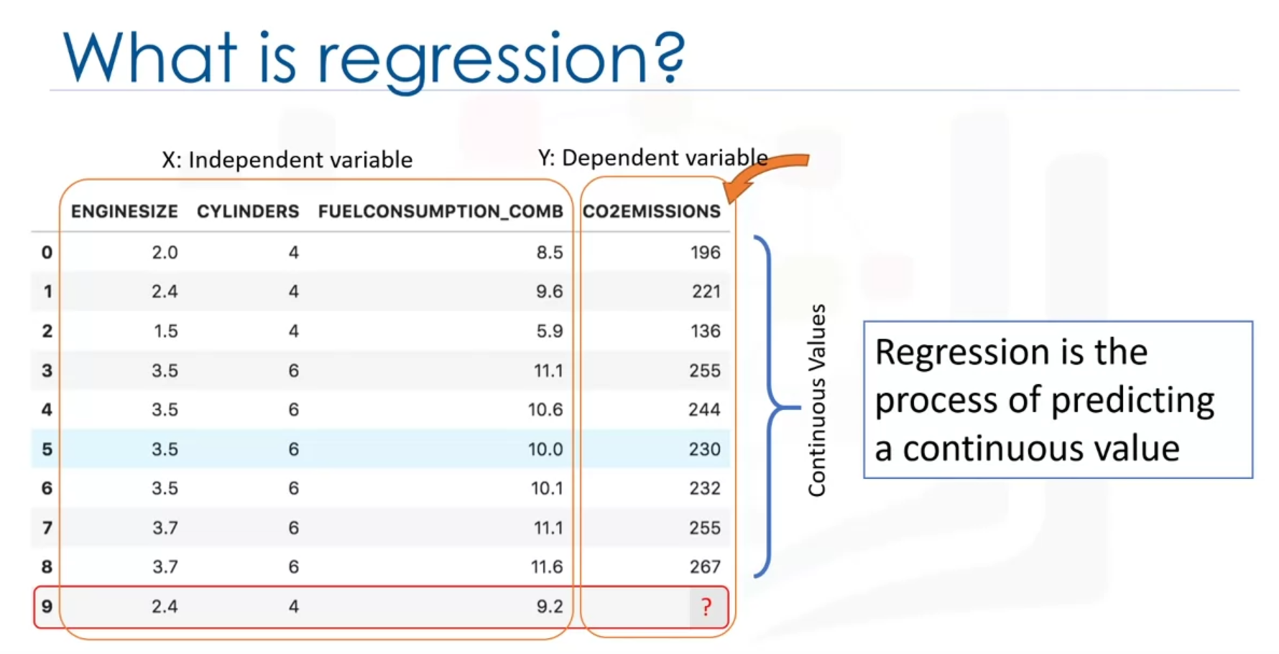

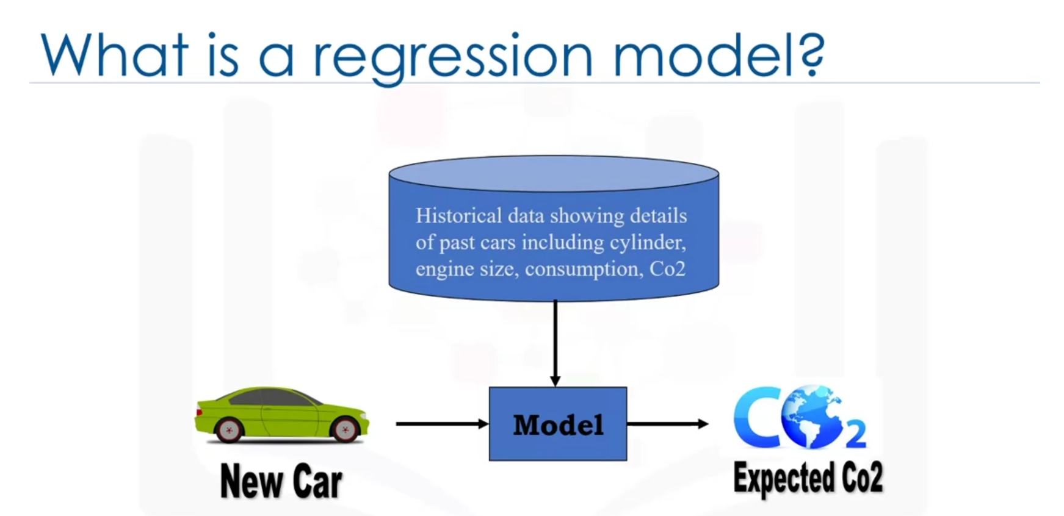

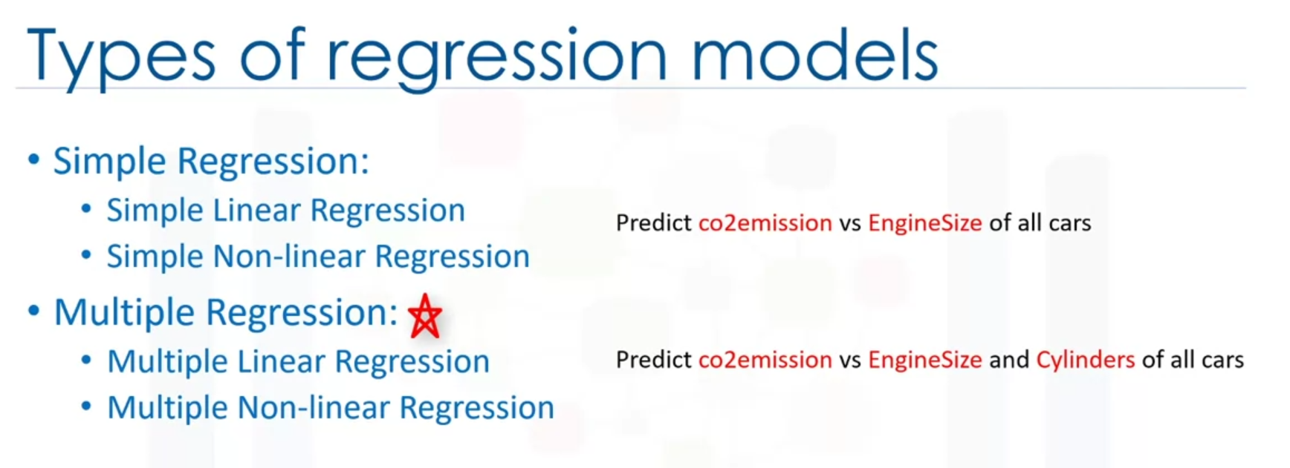

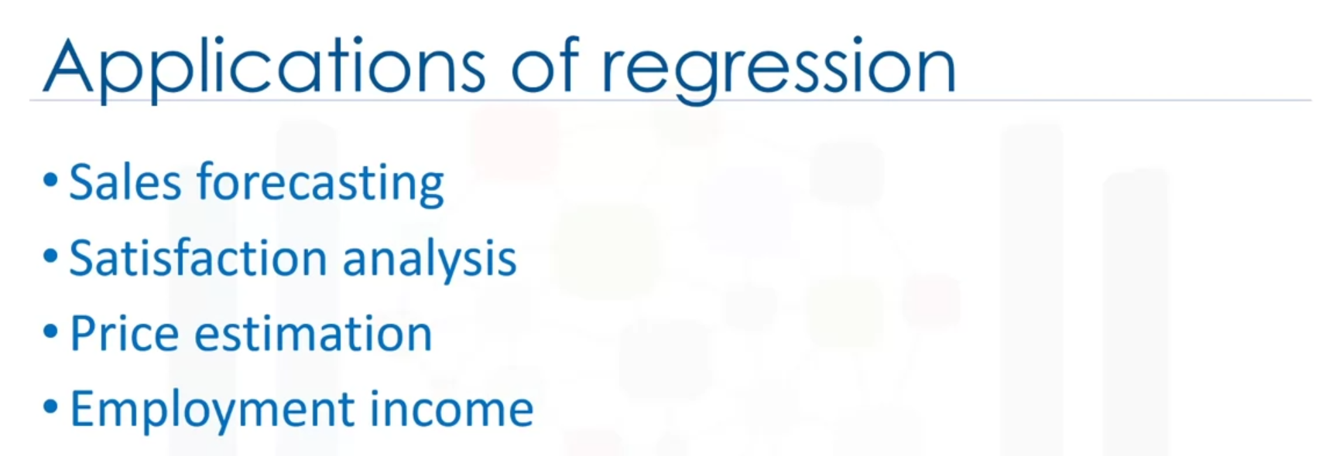

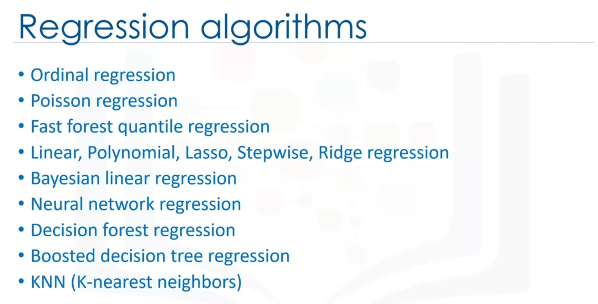

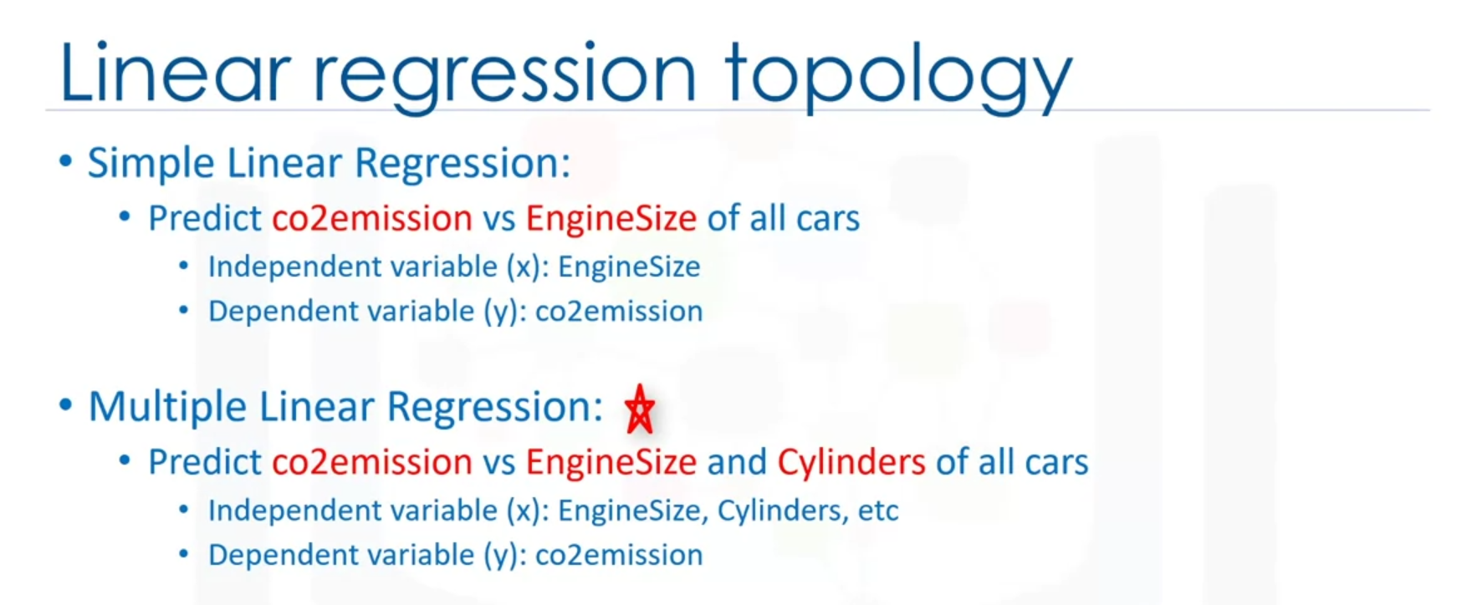

Independent variable – variable that is known.

Dependent variable – variable that you want to predict.

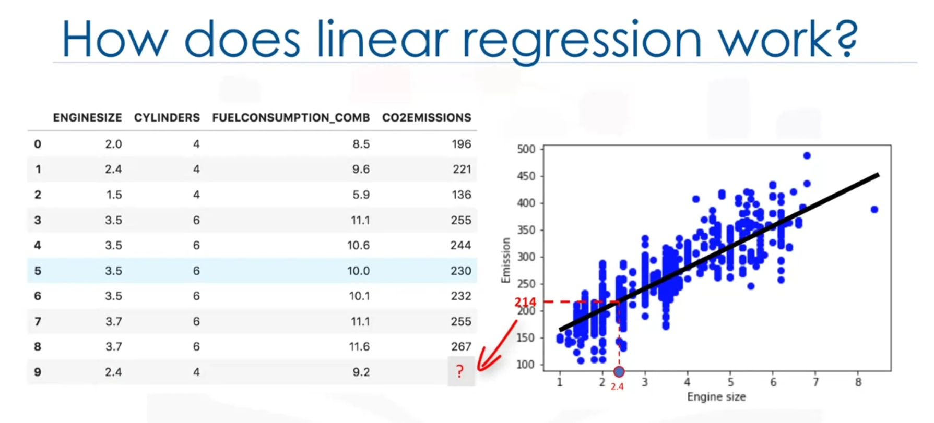

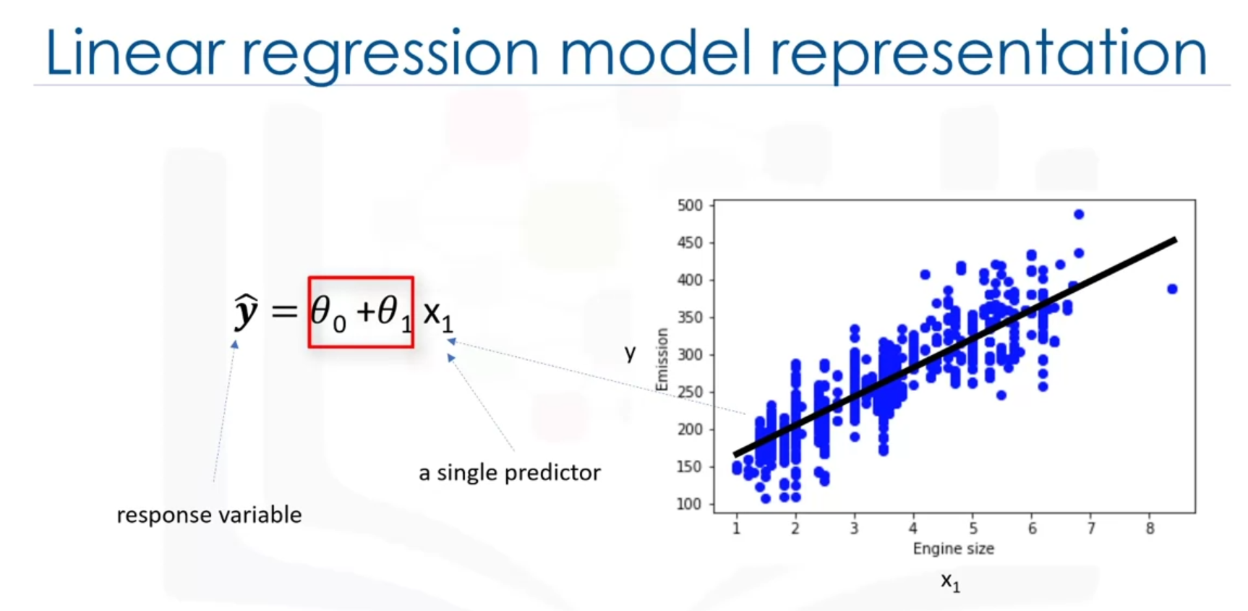

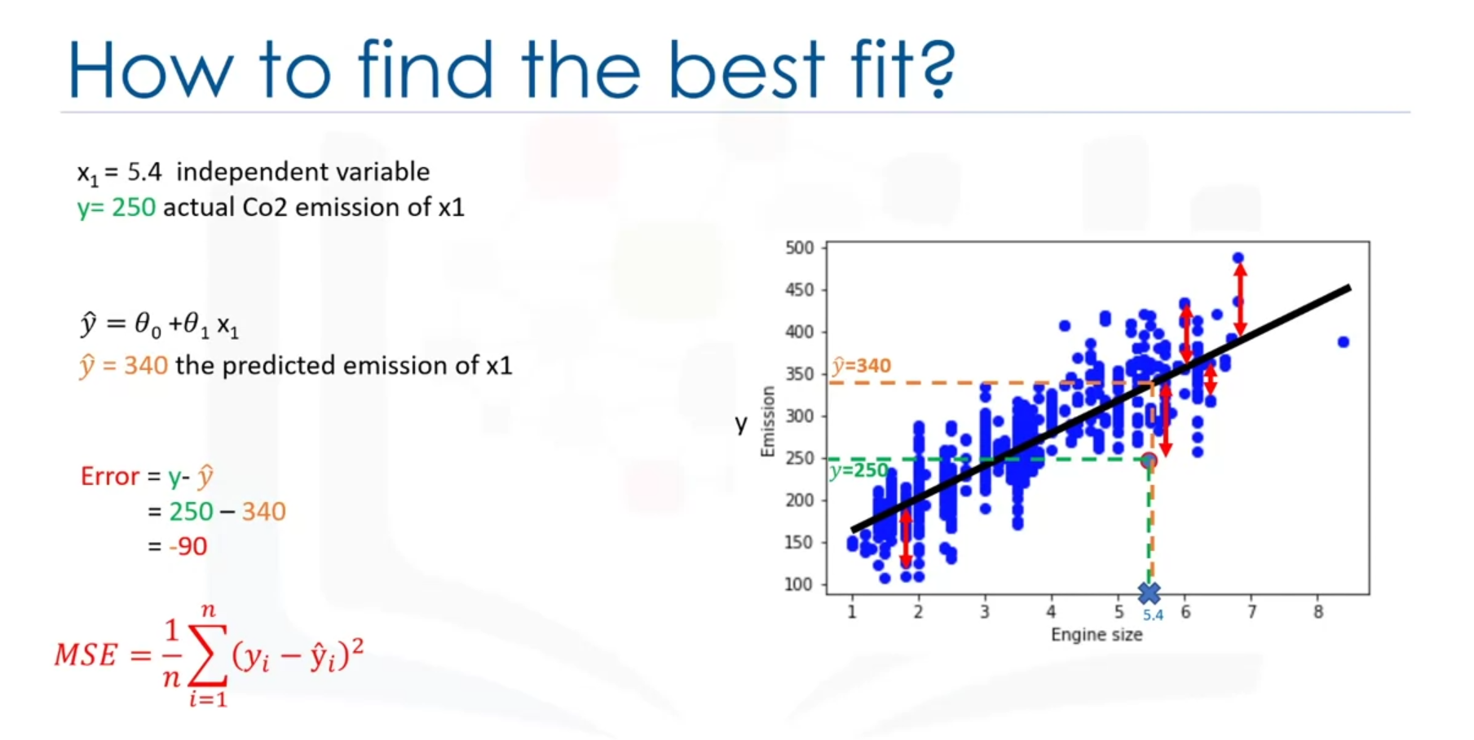

Error = residual error

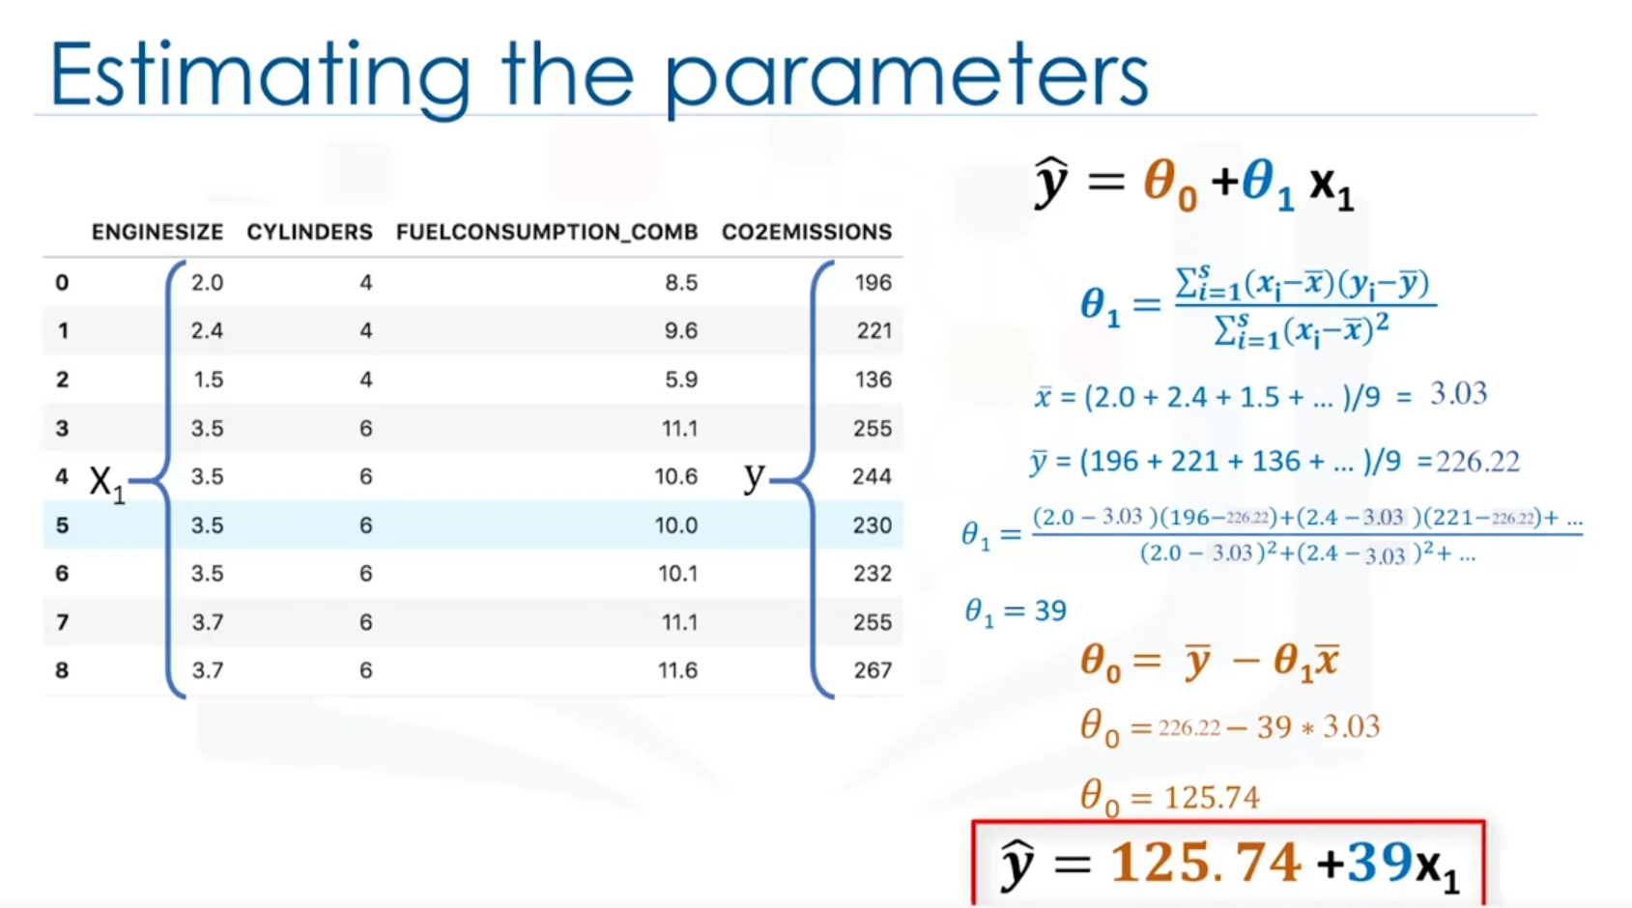

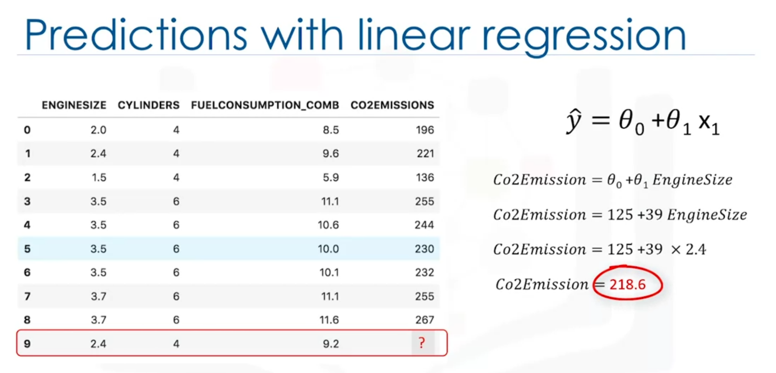

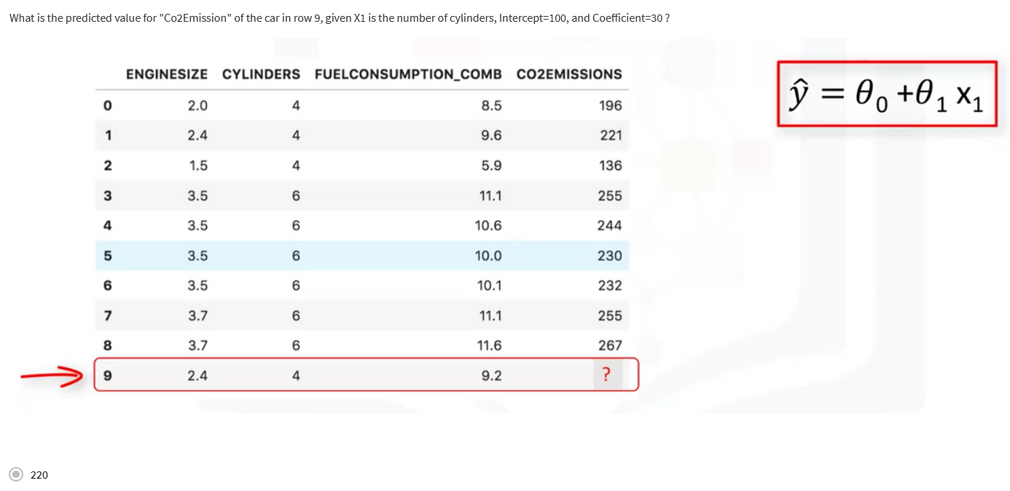

Theta0 is intercept and Theta1 is coefficient.

Y = 100 + 30 * 4 = 220

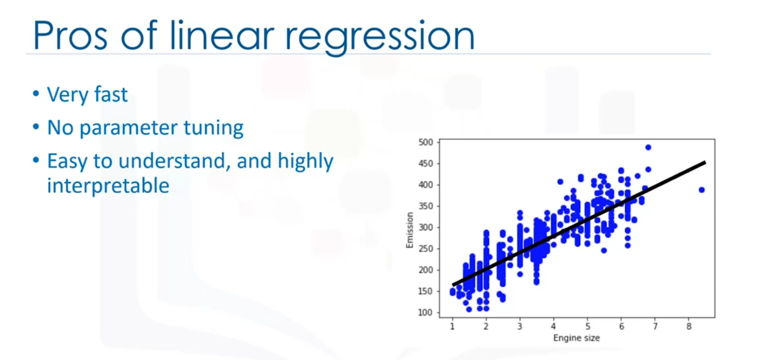

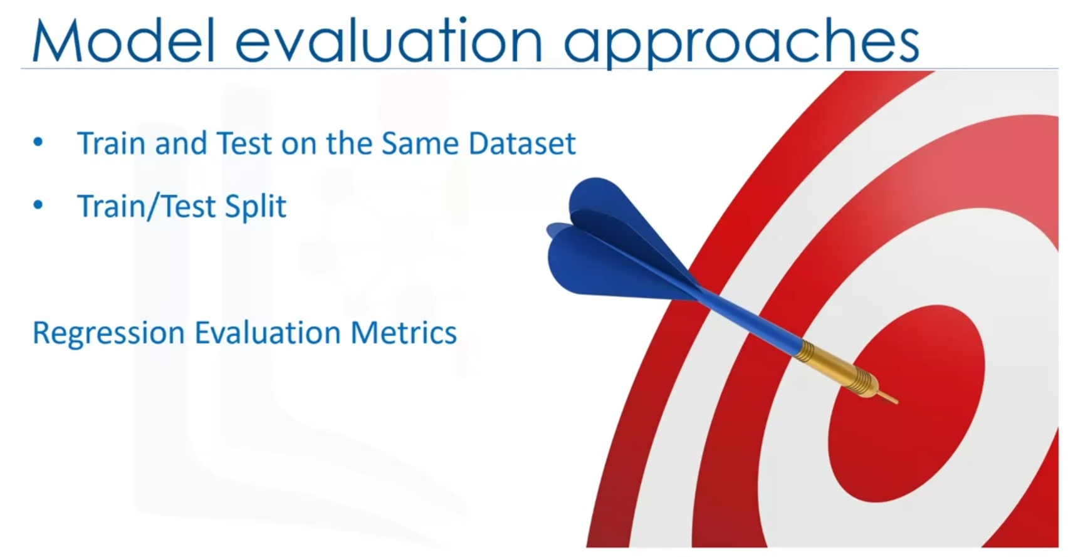

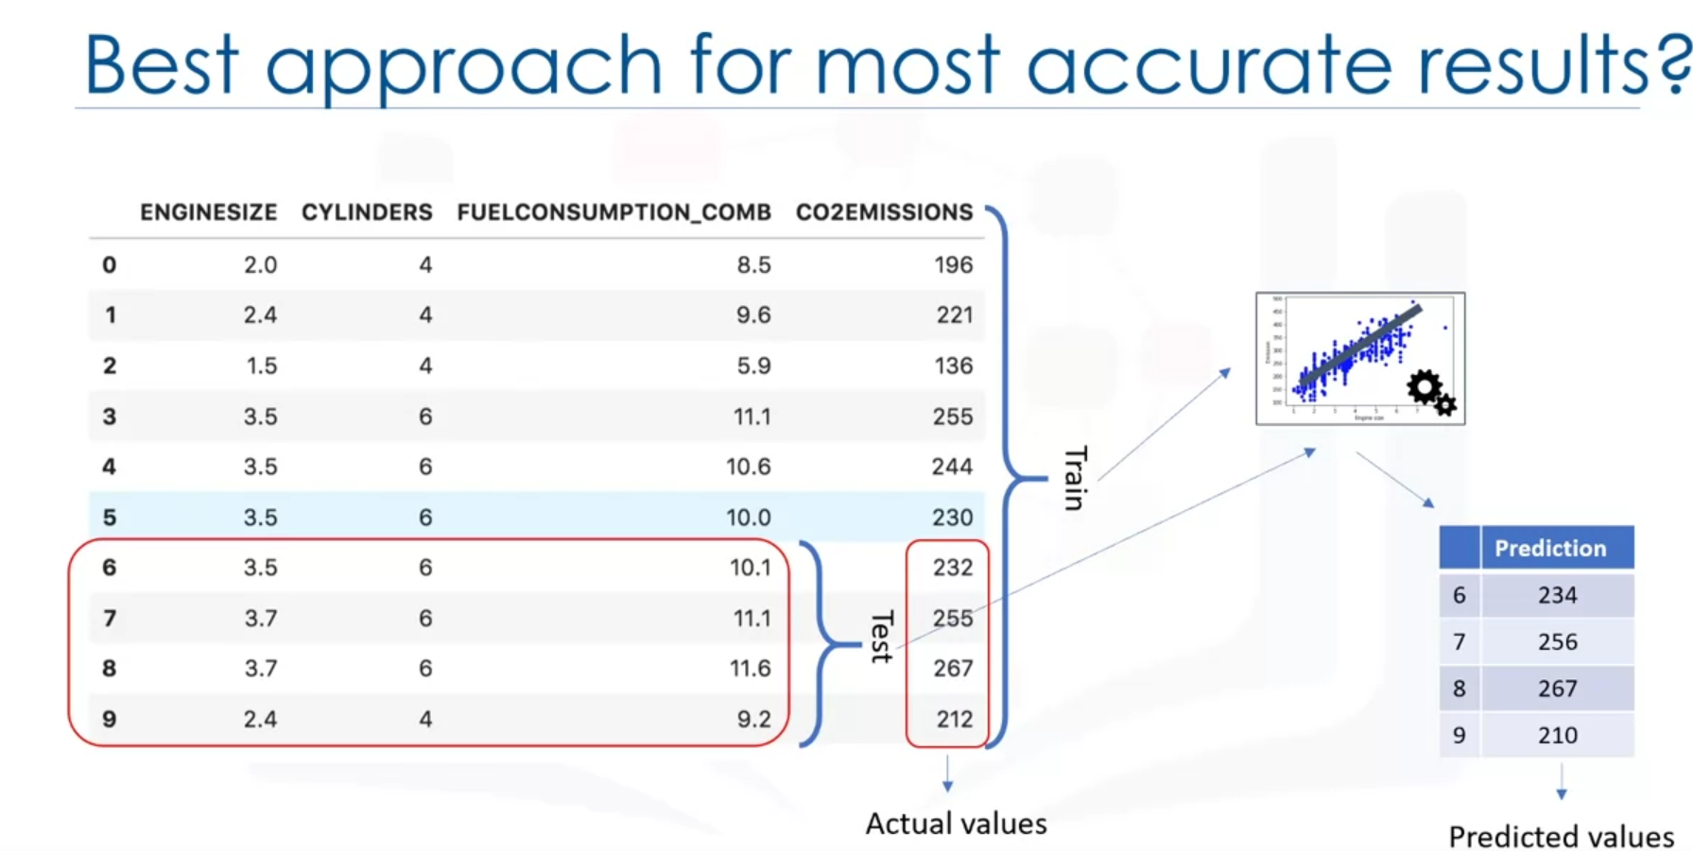

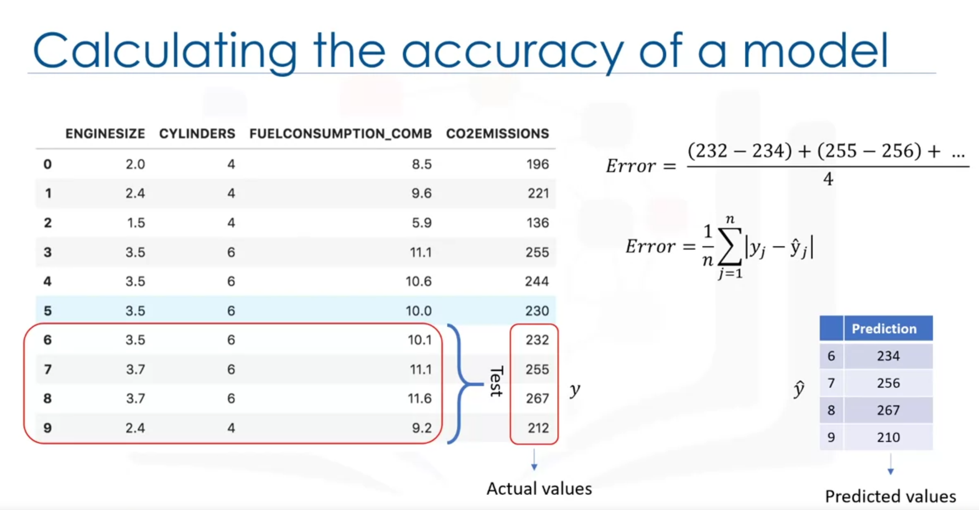

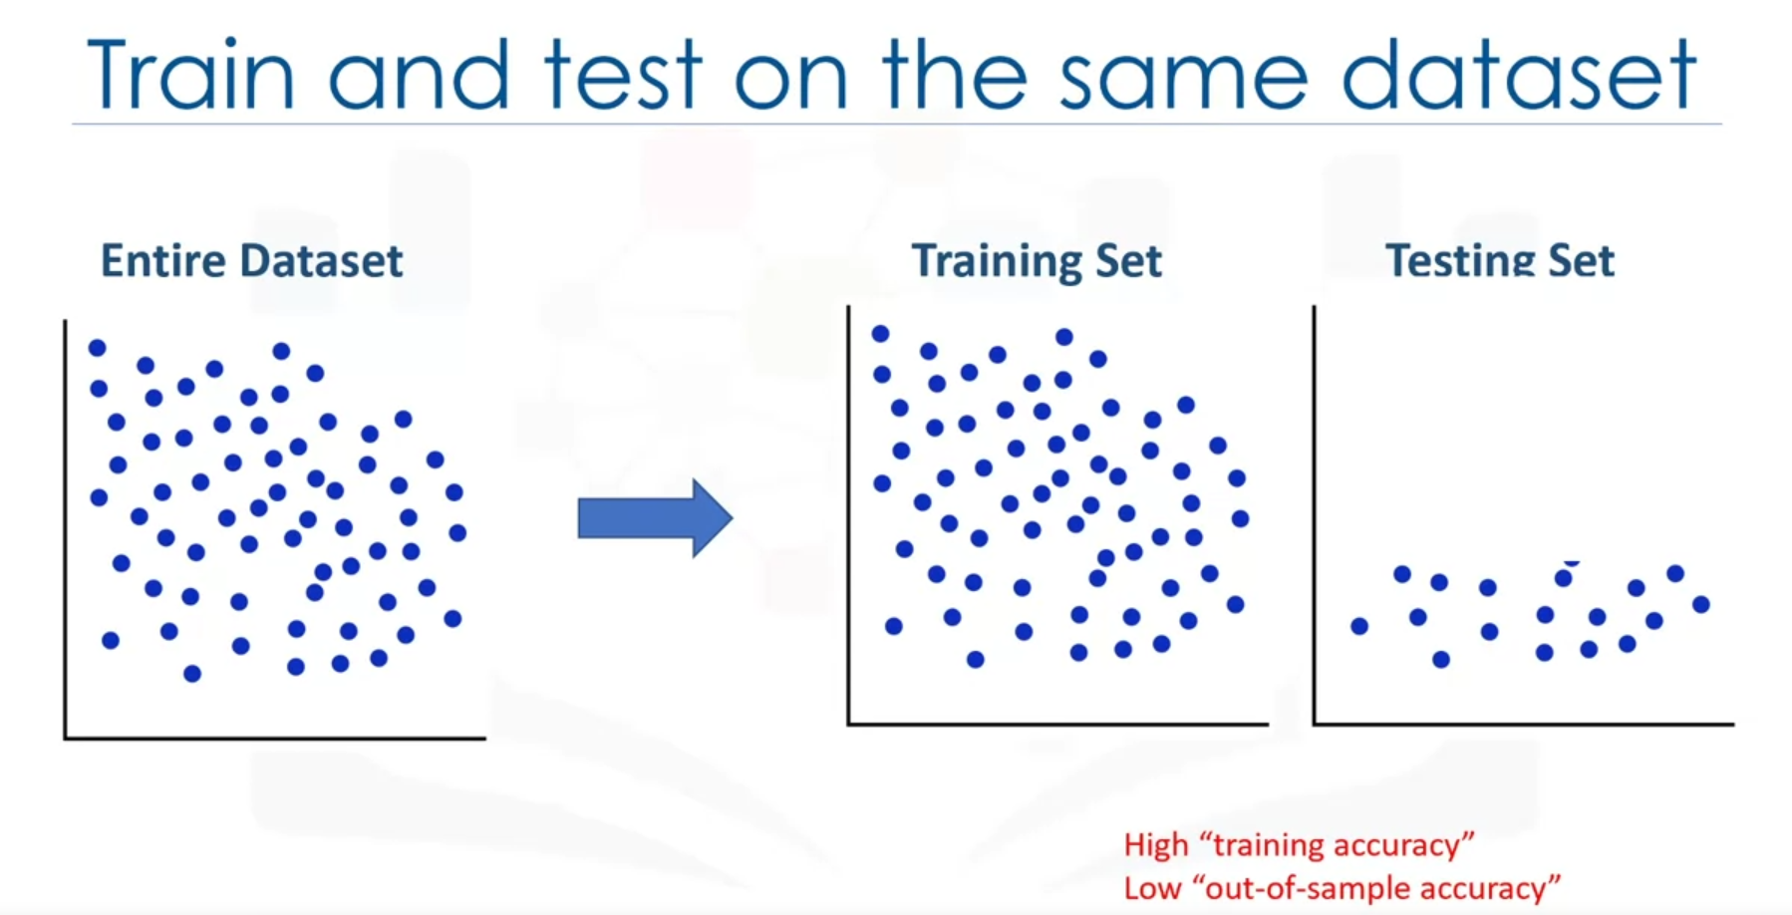

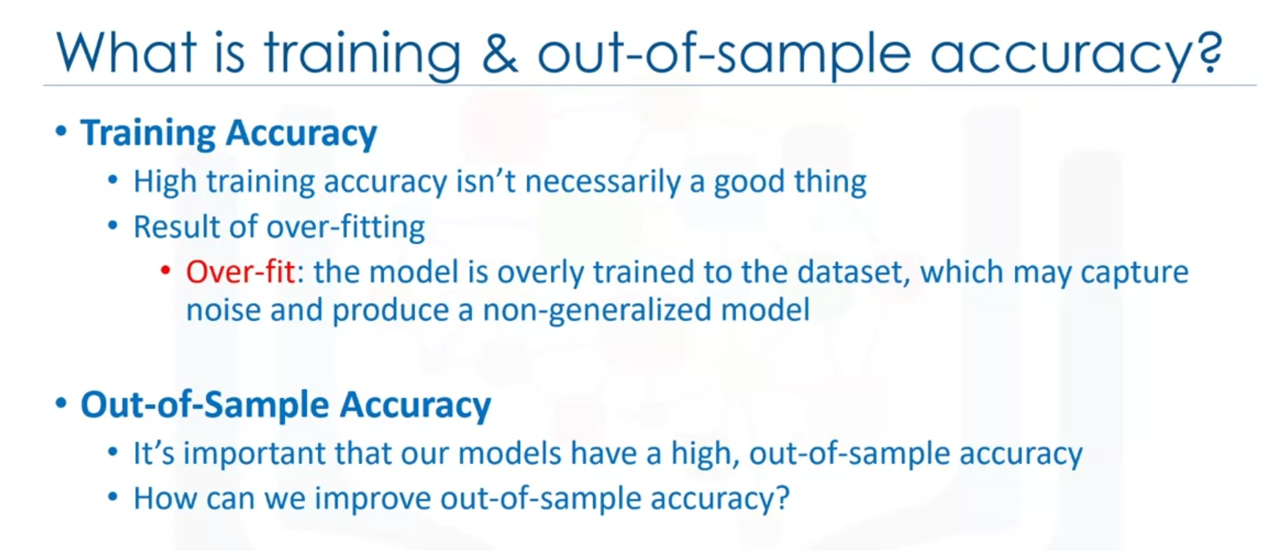

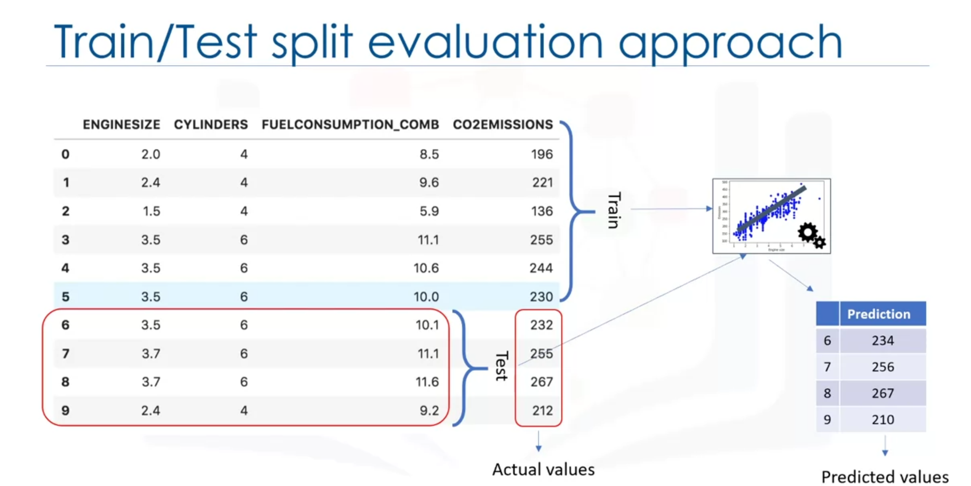

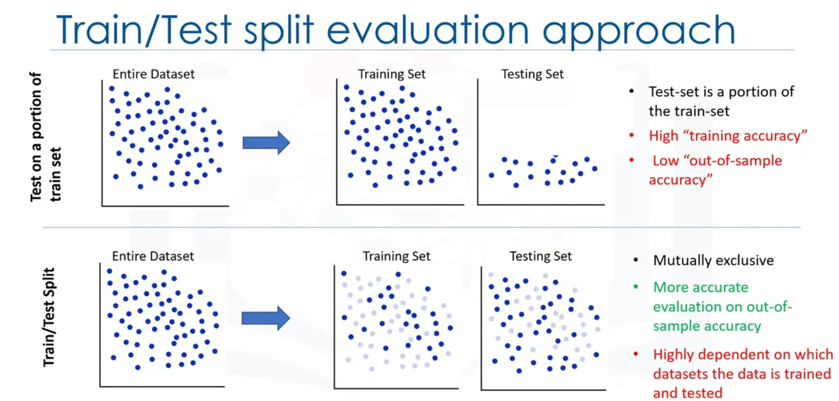

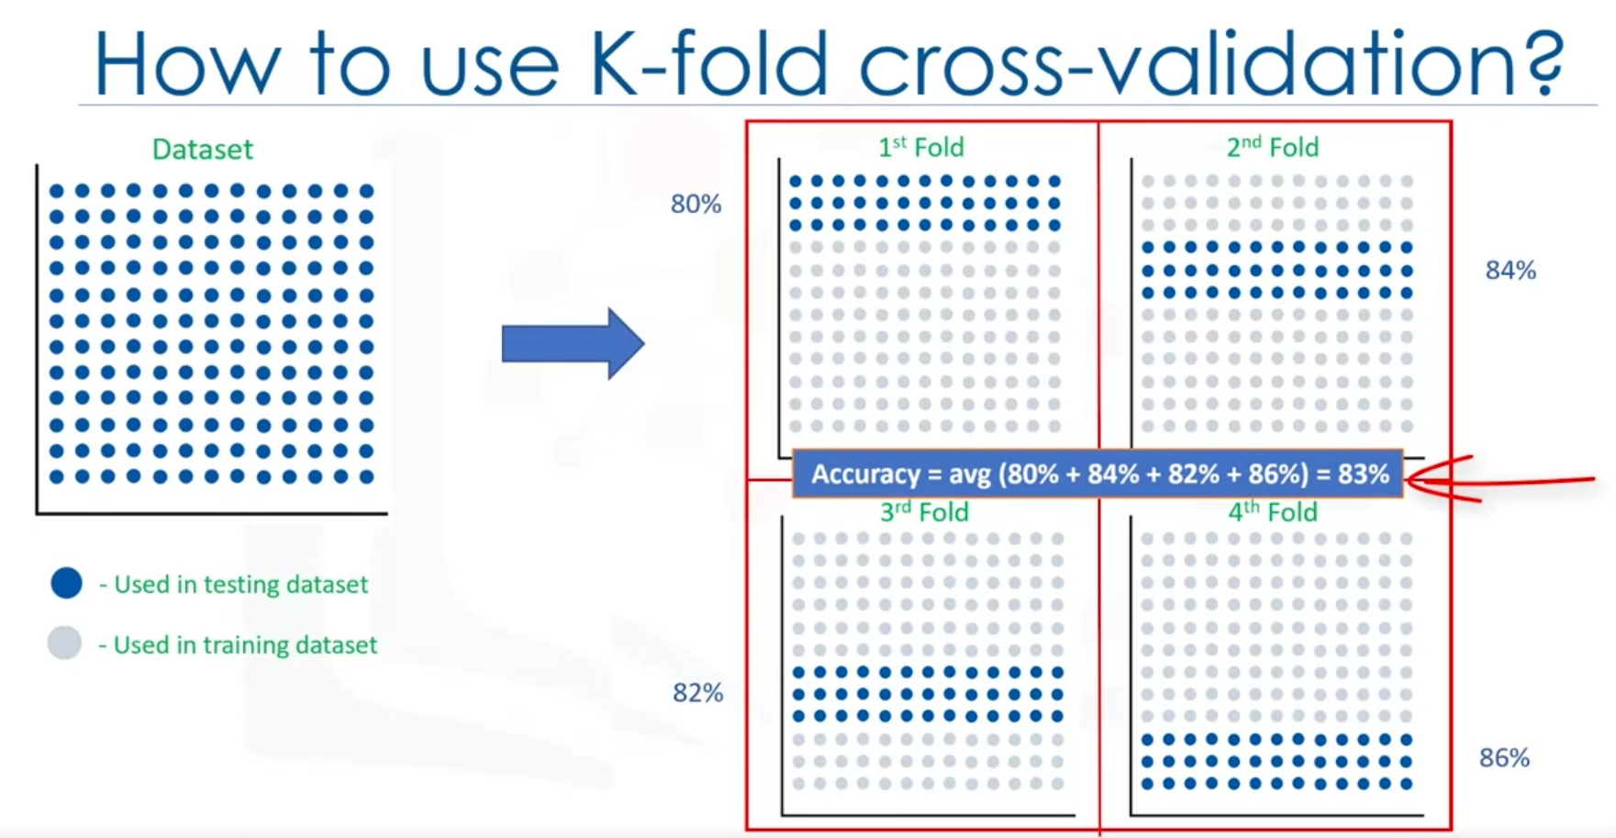

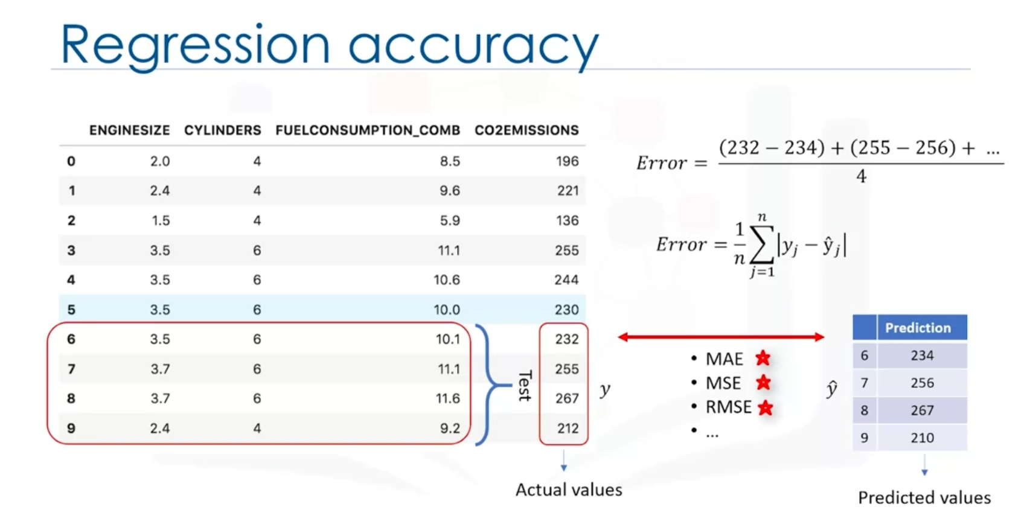

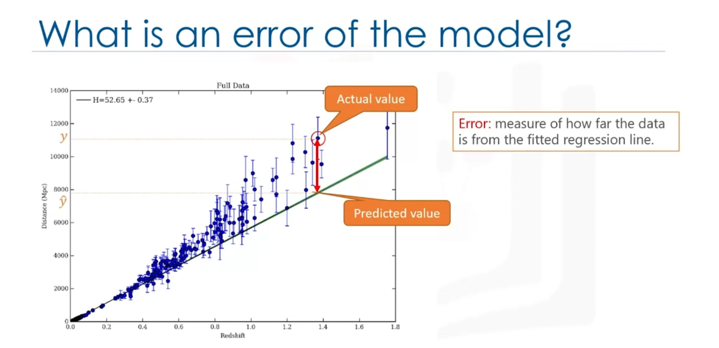

In the context of regression, what is the error of a model? The difference between the data points and the trend line generated by the algorithm.

* Mean absolute error (MAE),
* mean squared error (MSE),
* root mean squared error (RMSE),
* relative absolute error (RAE),
* relative squared error (RSE)
* R2 = popular metric for the accuracy of the model. The higher R2 the better the model fits your data.

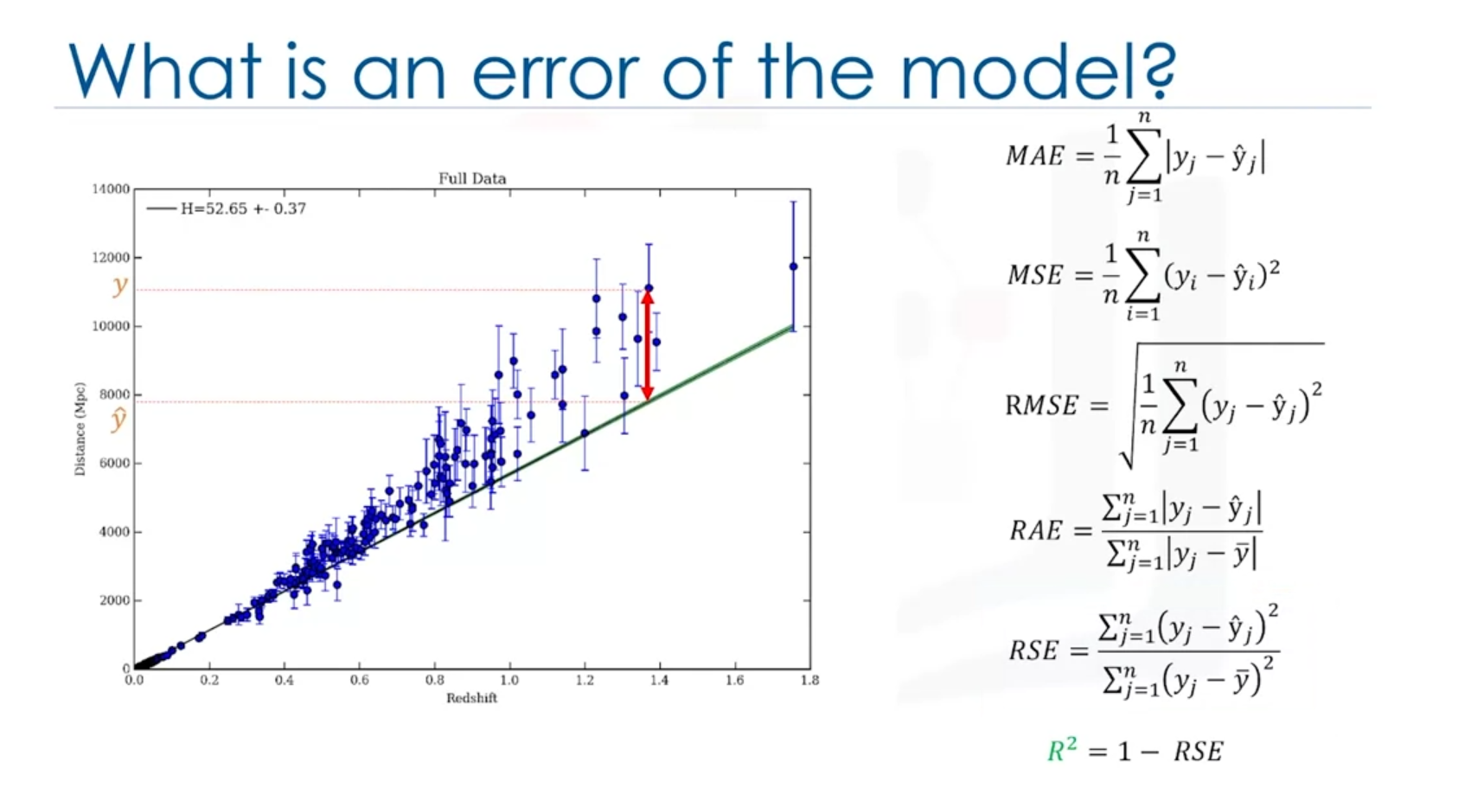

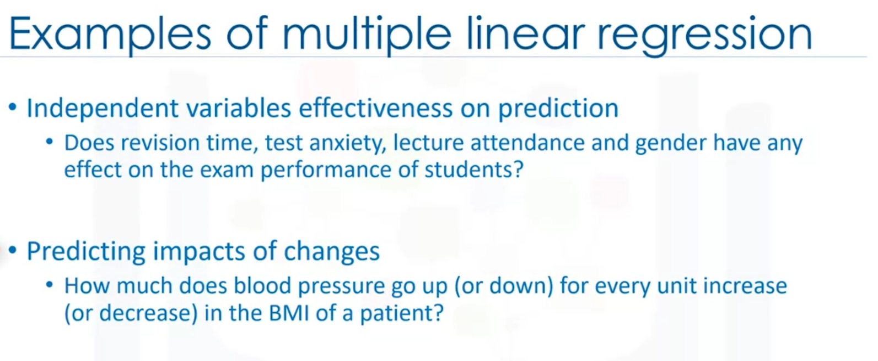

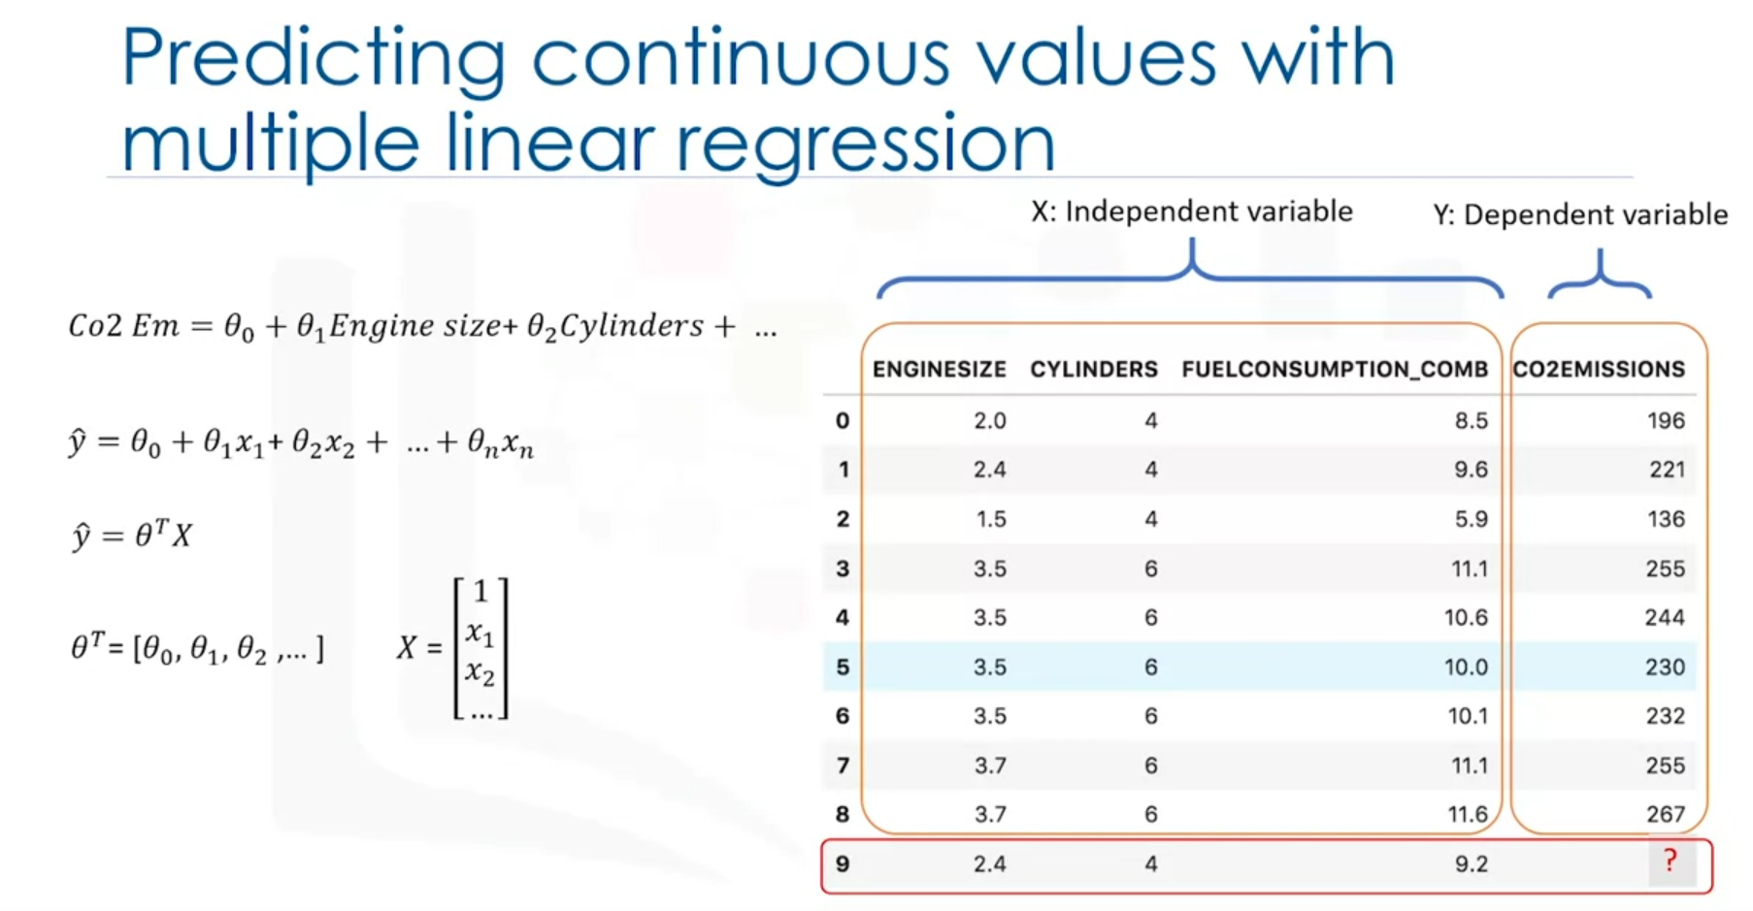

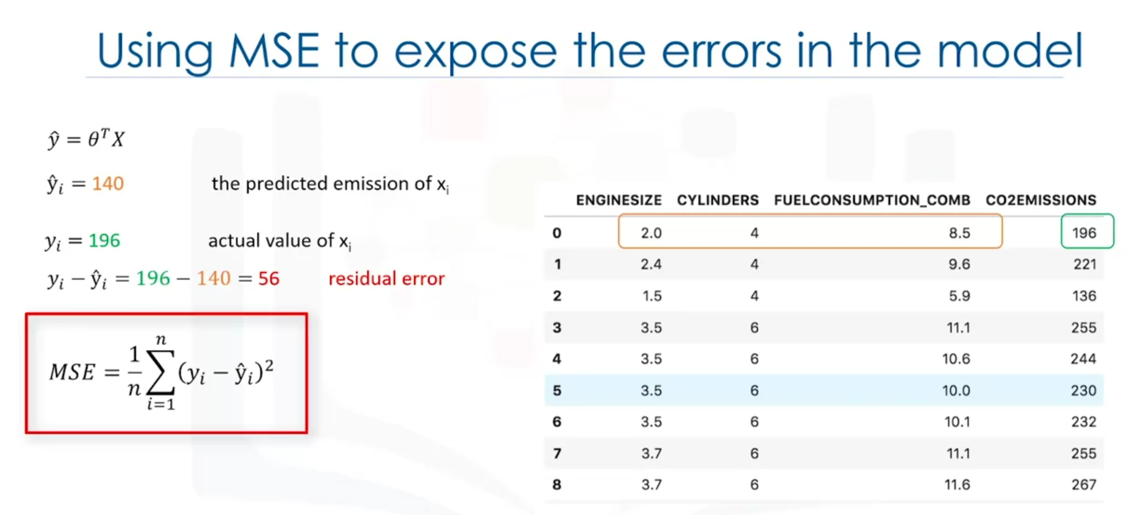

Objective is to minimize the MSE.

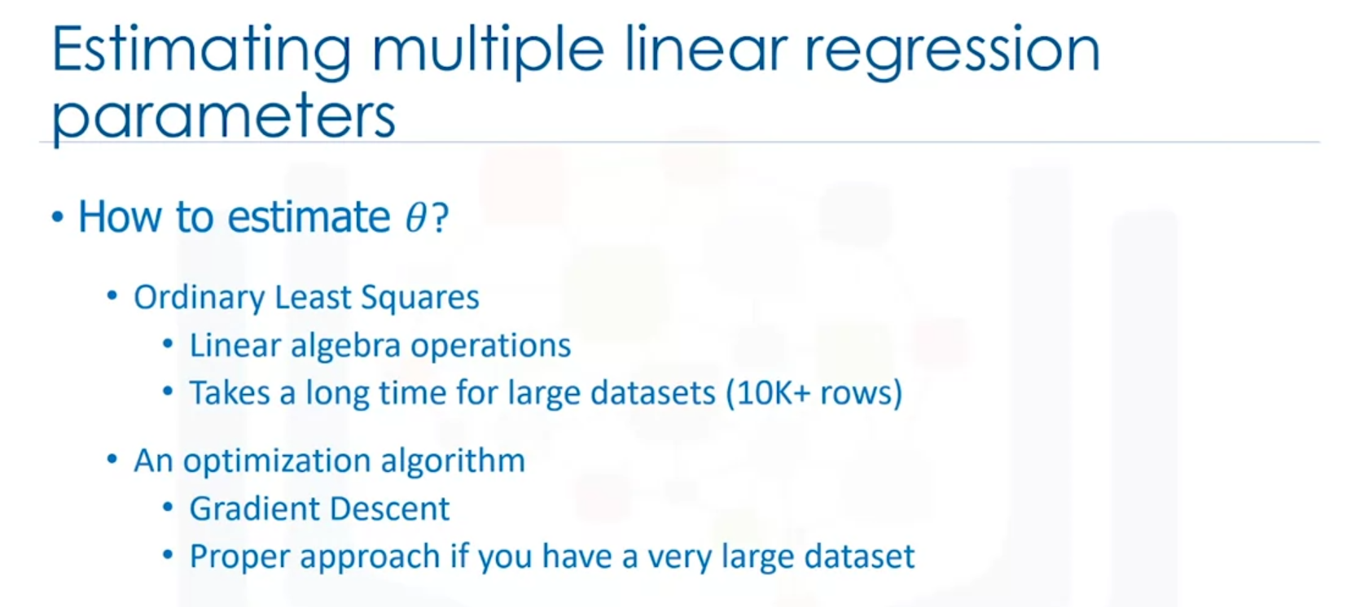

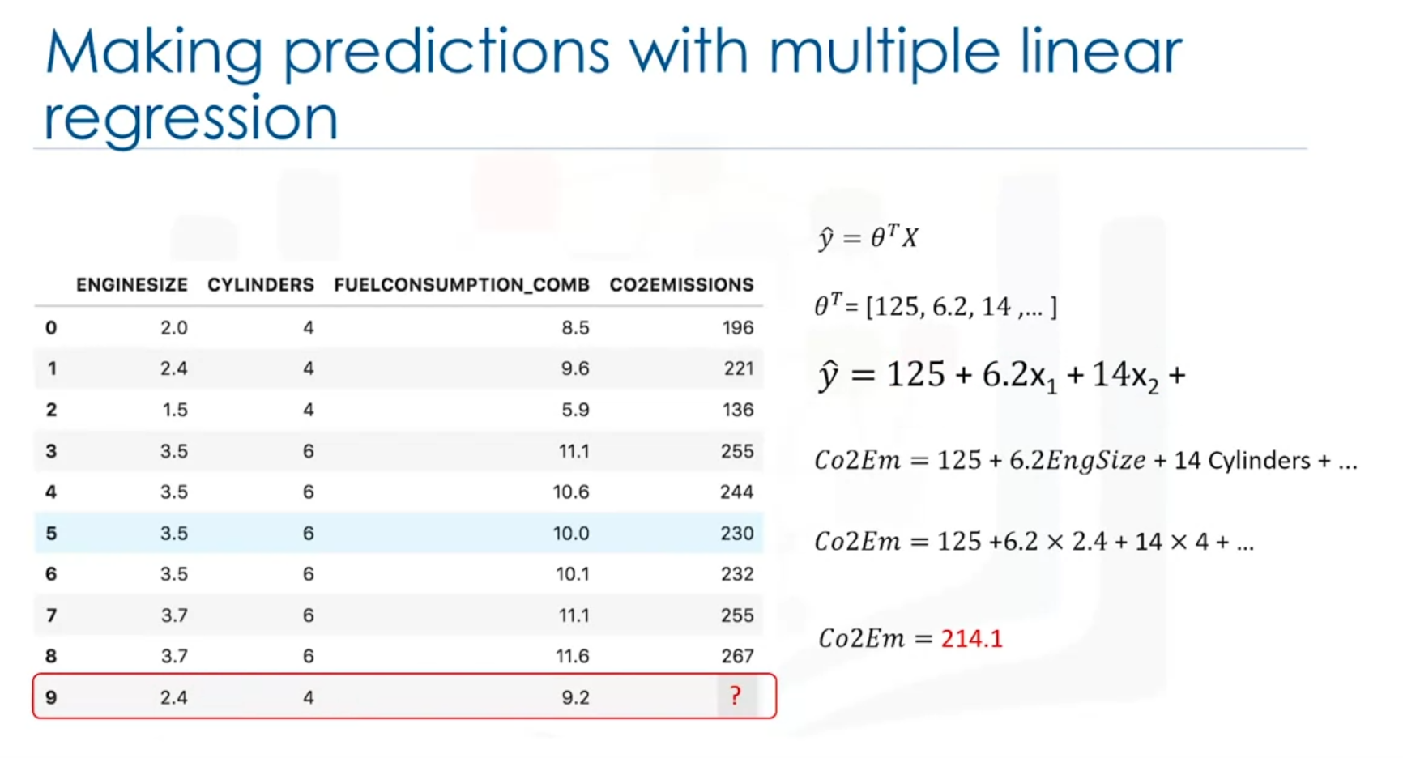

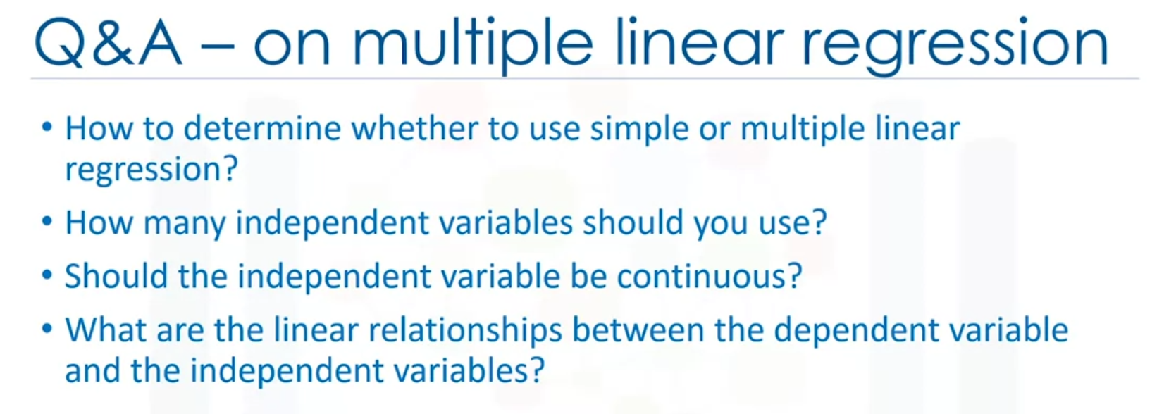

As a last point, remember that multiple linear regression is a specific type of linear regression. So, there needs to be a linear relationship between the dependent variable and each of your independent variables. There are a number of ways to check for linear relationship. For example, you can use scatter plots and then visually checked for linearity. If the relationship displayed in your scatter plot is not linear, then you need to use non-linear regression.

* "Out of Sample Accuracy" is the percentage of correct predictions that the model makes on data that the model has NOT been trained on.
* When should we use Multiple Linear Regression?
  + When we would like to identify the strength of the effect that the independent variables have on a dependent variable.
  + When we would like to predict impacts of changes in independent variables on a dependent variable.
* A linear relationship is necessary between the independent variables and the dependent variable.